Engineering Drawing Workflow Release Notes  
  
Release: 04/30/2020  
  
**A. Administrative functionality has been extended to allow someone with administrator rights to specify values for the following data points:**  
  
System Description  
Document Type  
Resource Type  
Name Assignments  
Priority  
DRNADCN  
White Board Number  
  
Ability to specify list of values for the above items is shown below.  
  
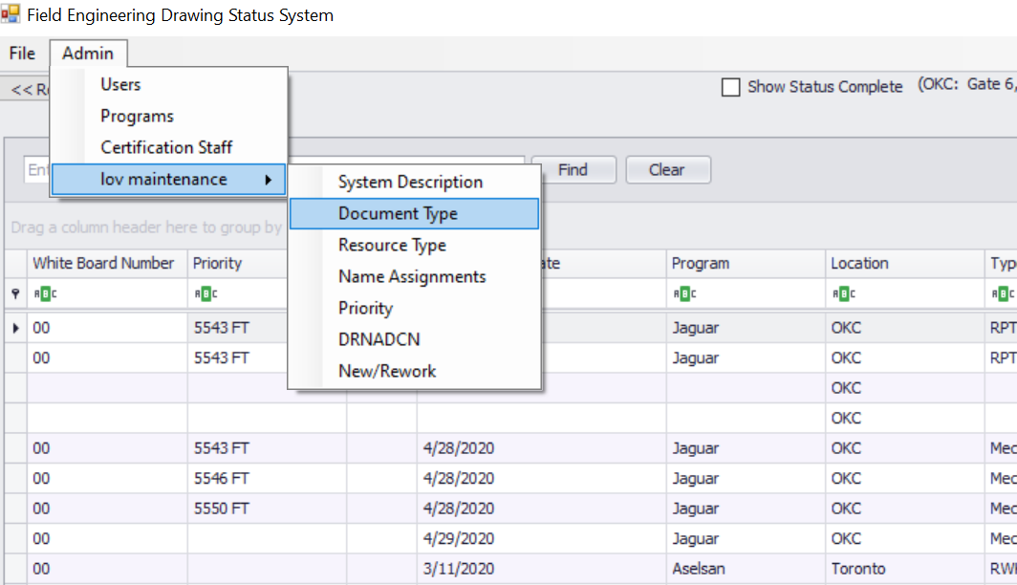  
  
**B. System Description**  
  
System description is a drop down that is tied the program selection. When a user enters a drawing request, the user selects the program and a list of values will populate in the system description drop down.  
  
**C. New Report/New Drawing versus Rework Report/Rework Drawing**  
  
A new field has been added to the workflow. This field is auto-populated based on the following criteria:

* User select document type, which determines whether it is a report or drawing. User then selects the document revision. This field is required now. A IR, P#, -, NC designates as New and anything else in the drawing revision field designates as rework.

**D. DwgRequestDate has been deprecated and replaced with the database column, DwgReqDate. DwgReqDate is a date datatype. This has been done to allow for proper filtering.**  
  
In the grid, pictured below the column header in the app has been changed to Document Req Date. The value is auto populated when a user enters a drawing request with the date the request was entered.  
  
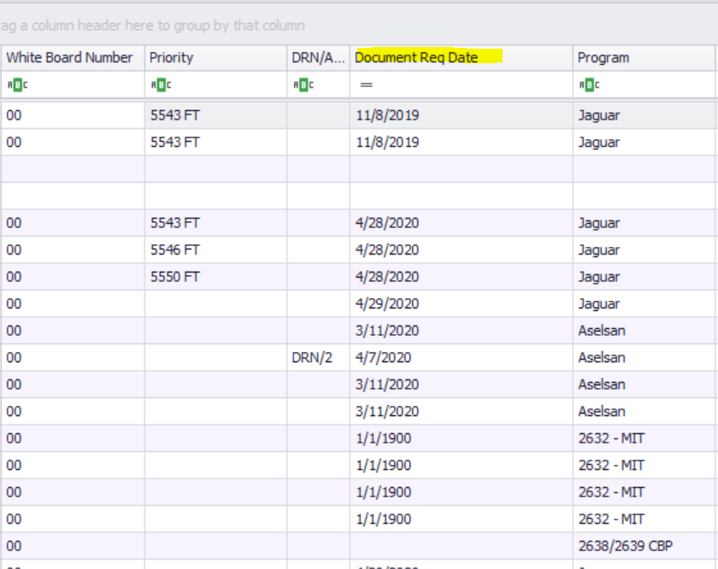  
  
**E. Planned Complete Dates (Drafter, Sr Engineer, etc. have been removed from the system)**  
  
All planned complete dates have been removed from the system. It has been determined that these fields no longer hold value.  
  
**F. Workflow fields have been renamed, generally replacing “Drawing” with “Document”  
  
G. Priority**Priority is a drop down with an lov administration capability. The priority is driven by the program that is selected. If a different record is selected in the data grid and the program is different from the last record selected, the lov will change for the priority column.  
  
**H. Drafter Name**Default drafter name to individual logged in when creating the drawing record.